**CSCI 582 Section 1 (Spring 2020)**

**Project 3**

**Sampling and the DFT**

The main purpose of this project is to explore sampling and discrete Fourier transform. I used python to write my program. The three major tasks for this project are as follows:

1. f(x) =

For the given function, if T = 256, sample the function. Plot both original and reconstructed signals in the same plot and comment on the accuracy of the reconstructions.

1. Compute the DFT of the given two images and produce a log-magnitude plot of the frequency spectra.
2. Apply ideal low pass and high pass filters to the frequency spectra from previous step and use inverse Fourier transform to reconstruct the filtered images.

I took x from 0 to 400 and plotted the given function f(x) in matplotlib. The function looks something like this:

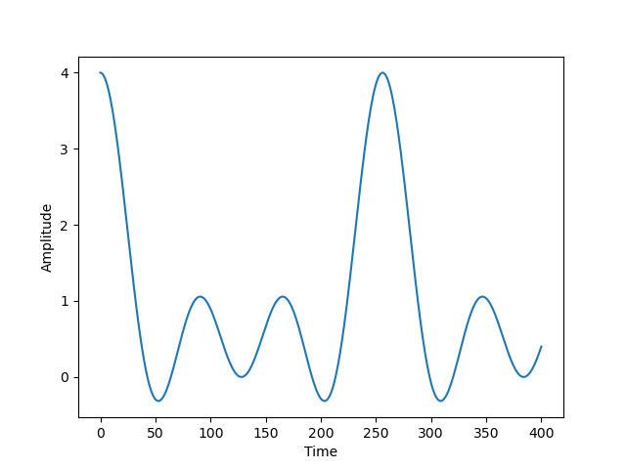

To sample the function, we need a sampling frequency that is at least twice the maximum frequency of our given function. The maximum frequency of our function is 3. So, we need at least the sampling frequency of 6 or greater in order to avoid aliasing. Let’s take the sampling frequency to be 10 and try to sample this function. The result is shown below.

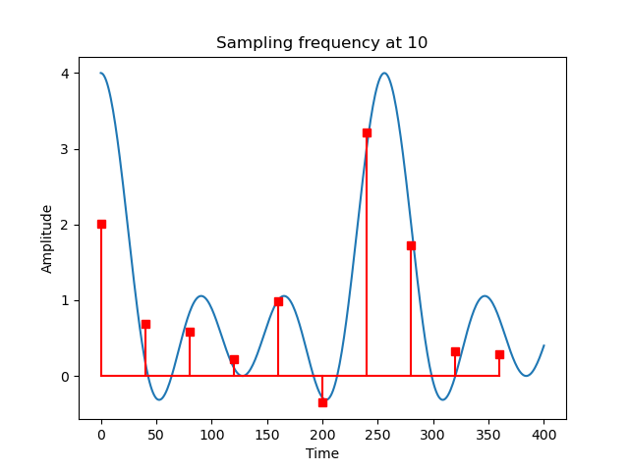

You can notice that the sampling does not look very great in this case. Let’s try with more sampling frequency, i.e. when sampling frequency: 20Hz and 100Hz

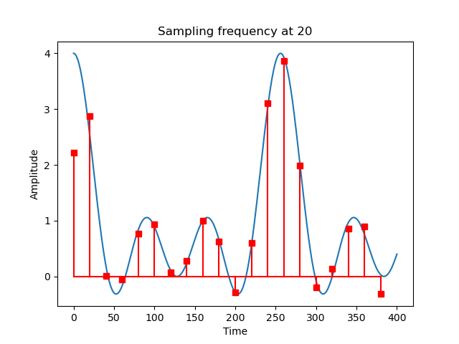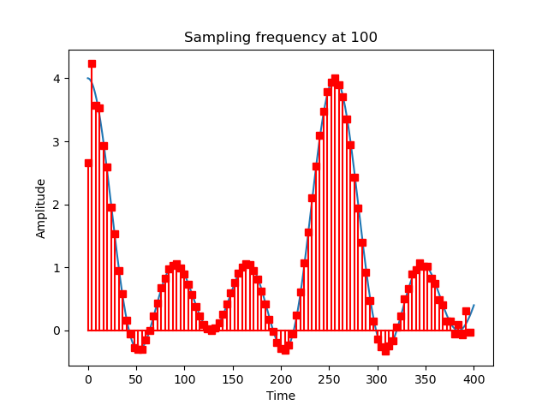

So, as you keep increasing the sampling frequency, the sampled function will look better and better and thus you can reconstruct your original function more accurately.

Now, let’s see the second part. I used the NumPy’s fft2() function to computer the DFT of the images. The results are as follows:

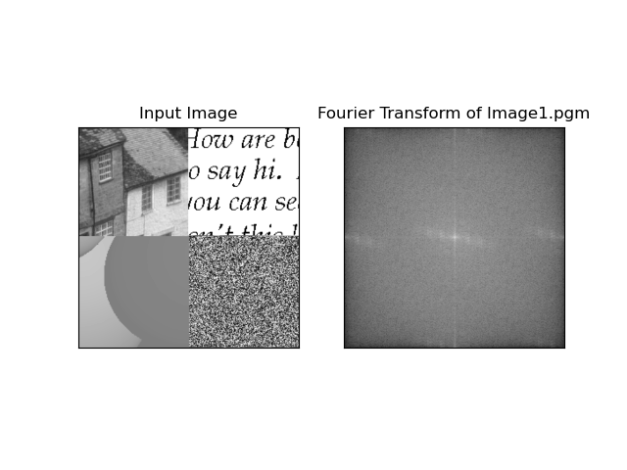

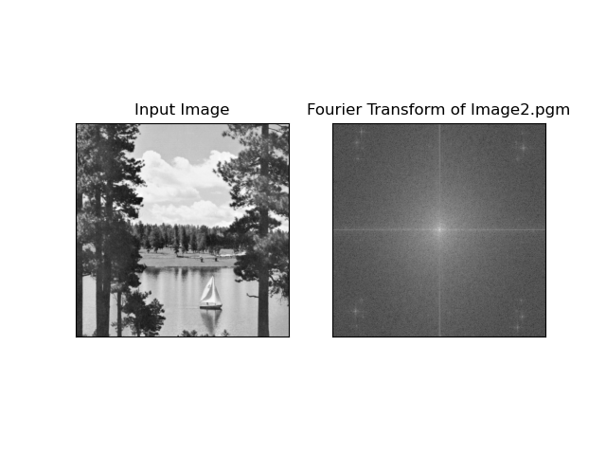

On the left is the original images and on the right is the frequency magnitude spectrum of the image.

For the third part of the project, we are supposed to use ideal low pass and high pass filter on the frequency spectrum of the image. As we know that low pass filter is used to remove noise from the image and make it smooth/blur. Likewise, high pass filter is used to sharpen the image and it is used extensively to edge detection. Below are the results:

High pass and low pass filter for Image1.pgm

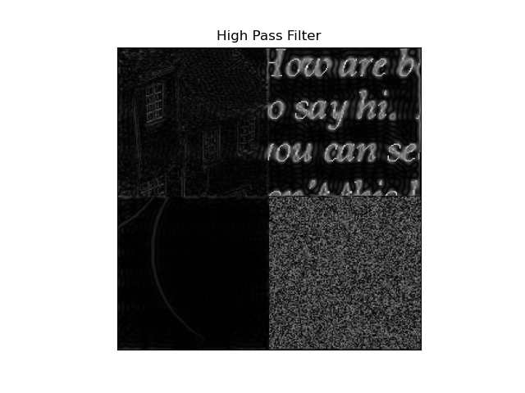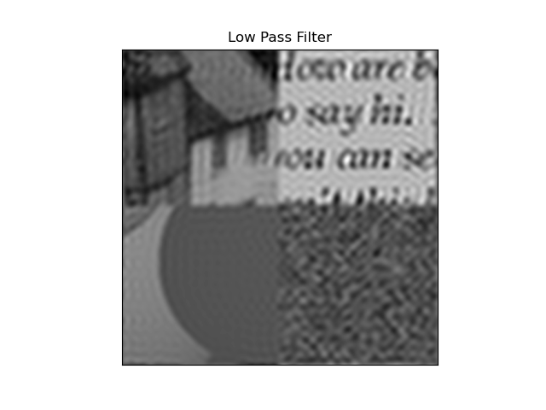

High pass and low pass filters for Image2.pgm

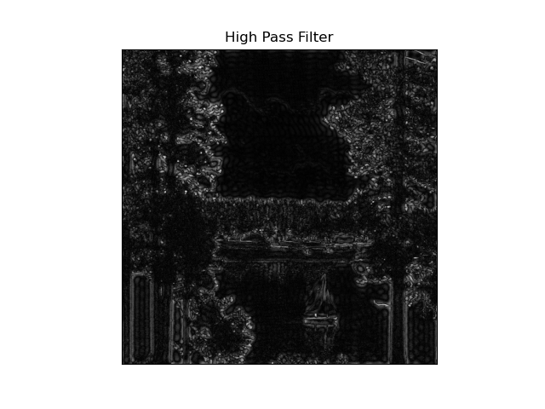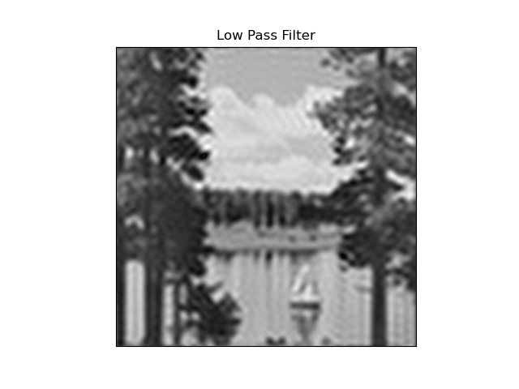

The above results are gained when the cut-off frequency is set to 30. Let’s look at the results when the cut-off frequency is set to 10

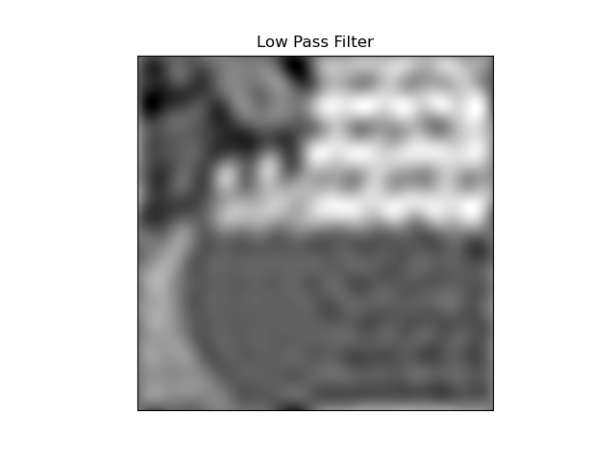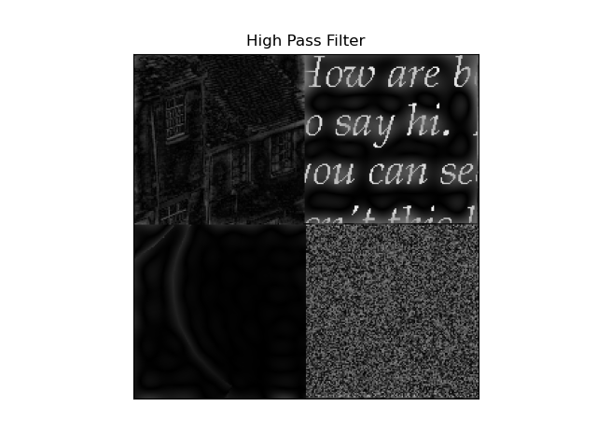

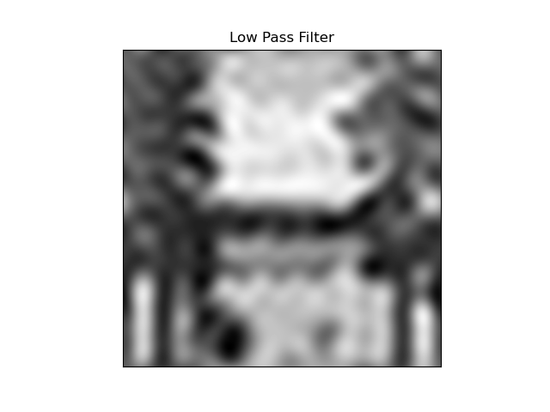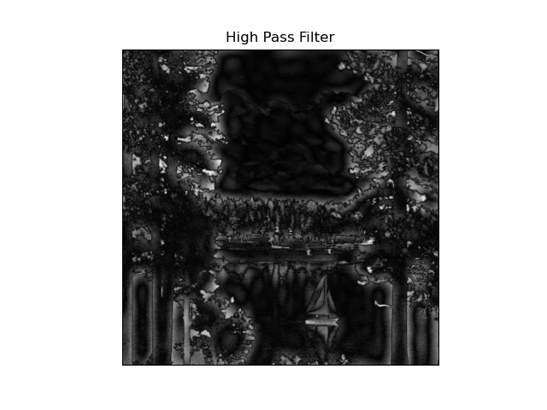

As you can see, when the cut-off frequency is set to 10, the low pass filter tries to preserve the frequencies lower than 10 and thus cuts the frequencies higher than 10 to 0. Thus, the image looks blurrier. Similarly, the high pass filter tries to preserve the frequencies higher than 10 and thus sets the frequencies lower than 10 to 0. Hence, the edges are more distinguishable.